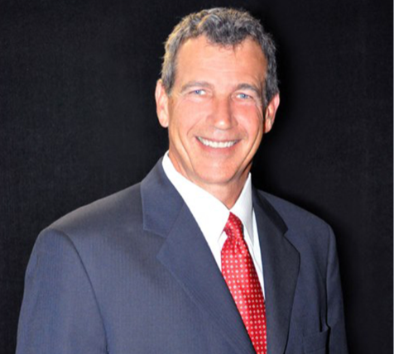

BIOGRAPHY – Roger Venables, Airport Systems Director City of Fort Worth

Roger Venables is graduate of the University of Texas at Arlington with 34 years of experience in government administration. He currently serves as Airport Systems Director for the City of Fort Worth responsible for operations, capital planning, budget preparation, and financial oversight of two city owned reliever airports; Meacham International and Spinks, with contract compliance and oversight of the Alliance Airport.

Prior to his appointment as the city’s Aviation Director in November 2021, he served as Assistant Director of the Property Management Department responsible for the acquisition, leasing and sale of the city’s real property assets, as well as mineral management, and utility administration. Venables currently serves as chair of the 2022 Bond Program Prioritization Committee and has previously served as co-chair for Fort Worth’s 2018 Bond Prioritization Committee.

Before the joining the city in 2016, Venables served in various capacities with the City of Arlington, Texas, from Real Estate Services Manager responsible for property acquisition and sales, leasing, and asset management, to Assistant Director of Community Development and Planning overseeing building permits and inspections, building plan review, zoning administration, and health inspections.

